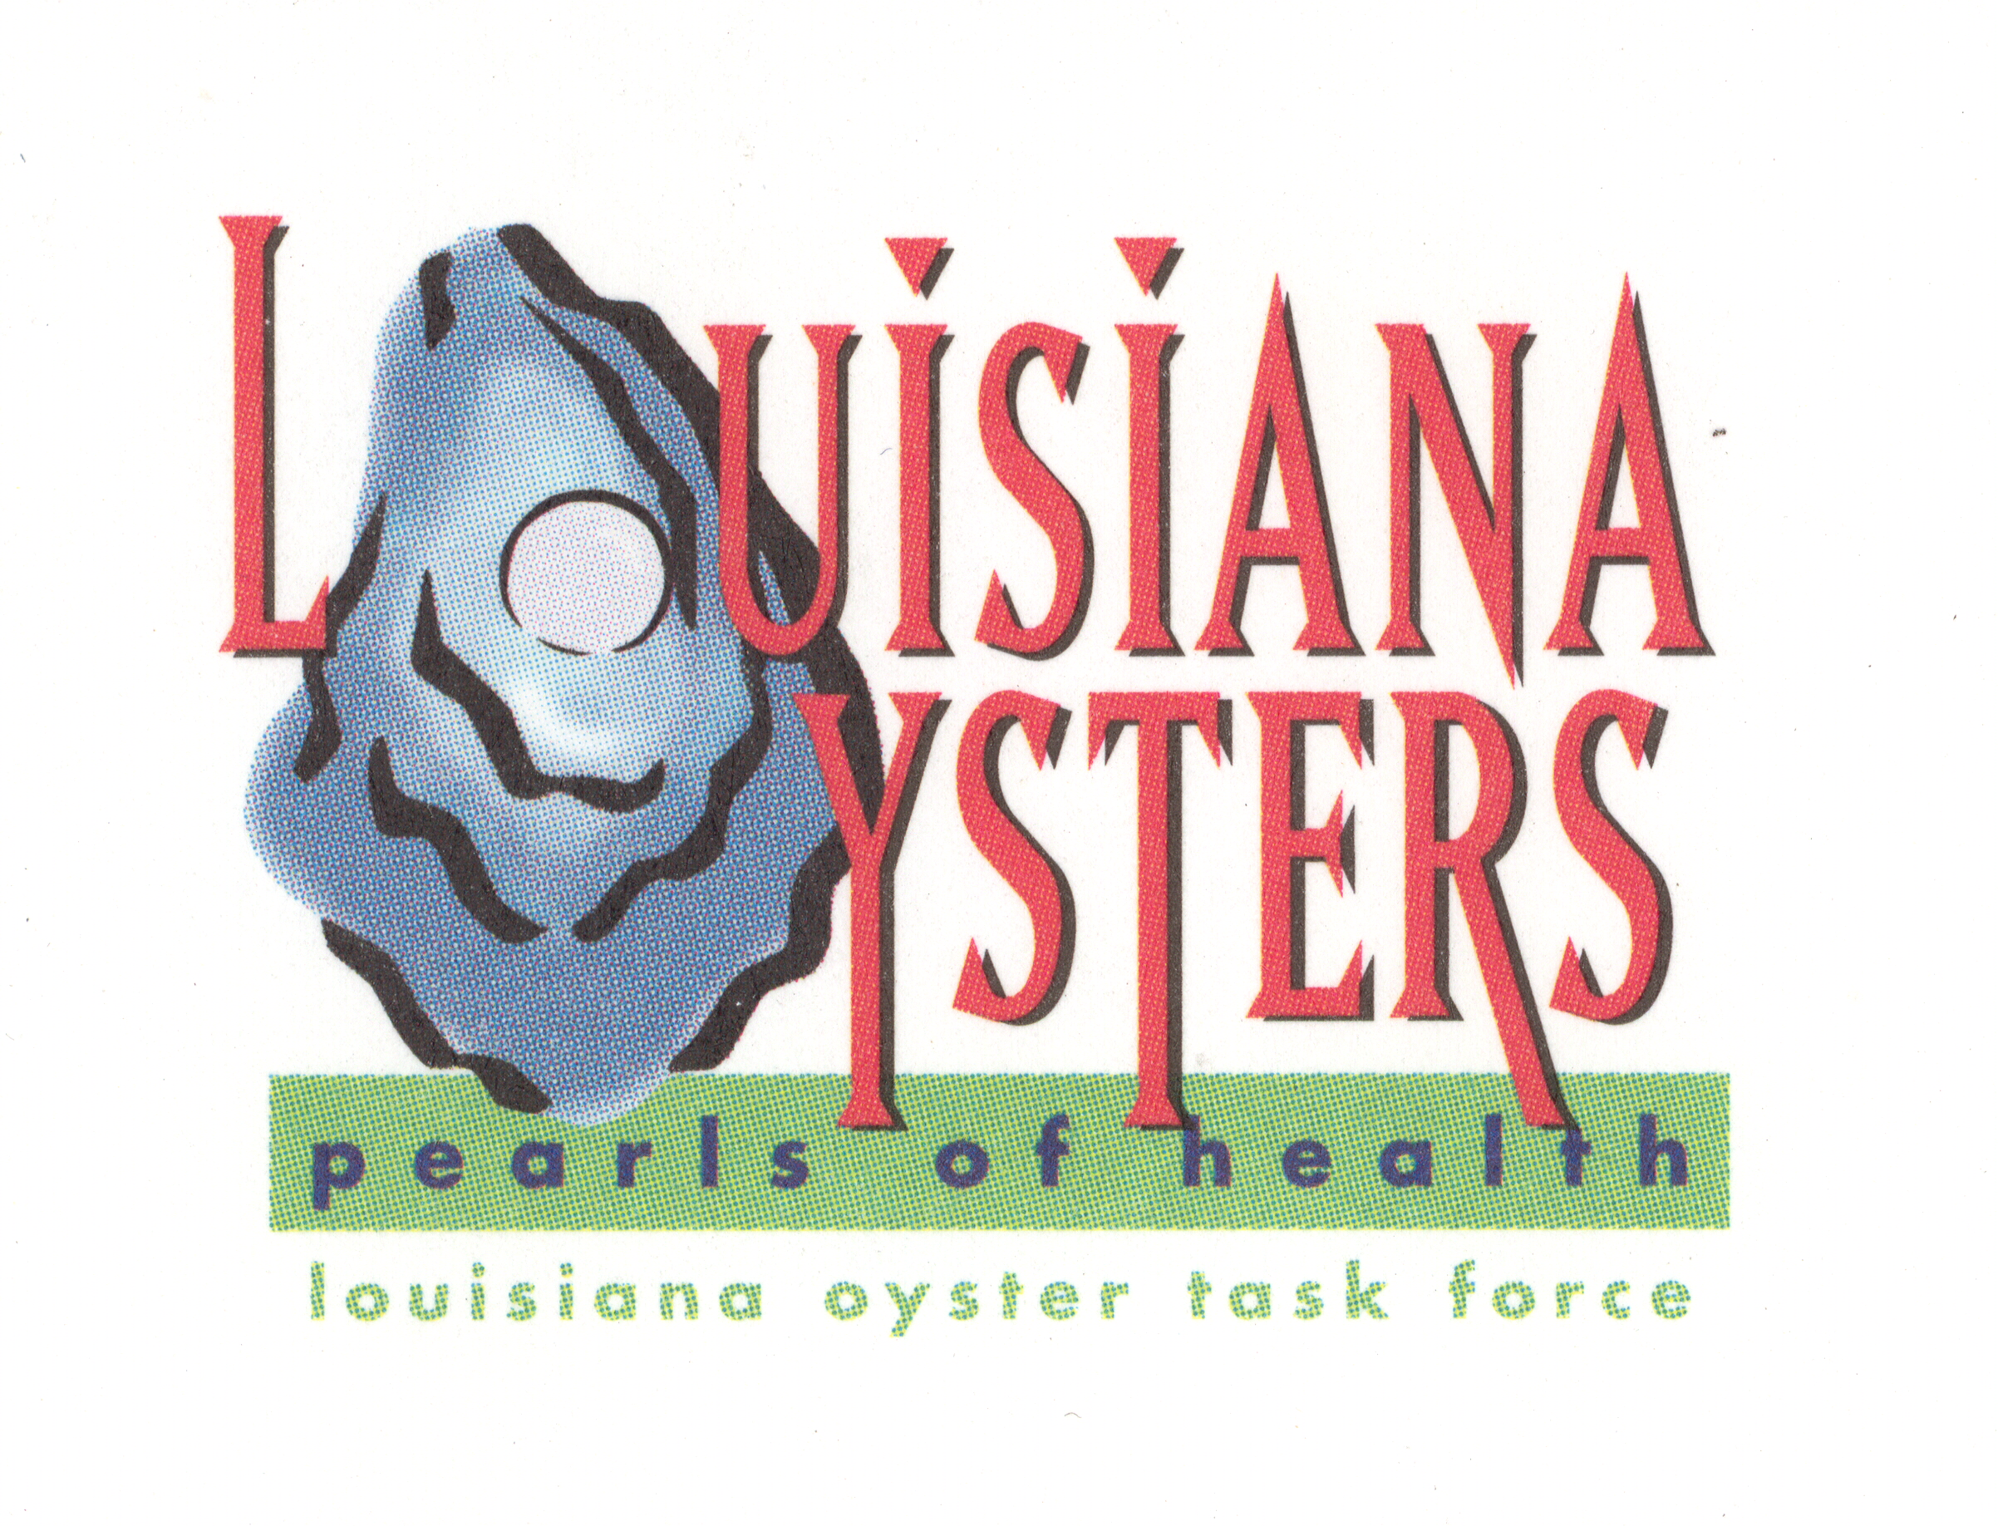

Louisiana Oyster Task Force Meeting
John Tesvich, Chairman

Tuesday August 23, 2011 1:00 PM
UNO Advanced Technology Center, 2021 Lakeshore Drive, Suite 210
AGENDA

- Roll Call
- Approval of May 10, 2011 MINUTES, Approval of August 3, 2011 MINUTES
- Treasury Report
A. Oyster Tag Sales
B. LOTF Budget
IV. Committee Reports
A. Public and Private Oyster Grounds Committee – (Buddy Pausina)
B. Enforcement - (Steve McManus)
C. Legislative - (Jakov Jurisic)
D. Research – (John Supan)
E. Coastal Restoration – (Dan Coulon)
F. Marketing - (Dana Brocato)
G. Health – (Glenn Cambre)
V. Old Business
    - BP Oil Spill Remediation
      - Claims Process
      - Public Reef Remediation
      - Oyster Lease Remediation
    - Oyster Lease Moratorium Update
    - Sabine Lake Oyster Reefs Update
    - Public Oyster Reef Evaluation & Shell Plants – Patrick Banks
VI. New Business
- 2011 – 2012 Public Seed Ground Season Recommendations
- “Louisiana Wild” Seafood Certification Program-Joey Shephard (WLF)
- Interstate Shellfish Sanitation Conference/proposal list – DHH and Al Sunseri
E. LOTF sponsored ISSC Hospitality room (Al Sunseri)

- Set Next Meeting
- Adjourn

